How to install your 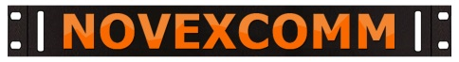 Mounting Brackets
This guide shows the LDG series tuner but works for many items
You need a Rivet-Nut setting tool with 8/32 tip & aluminum nuts
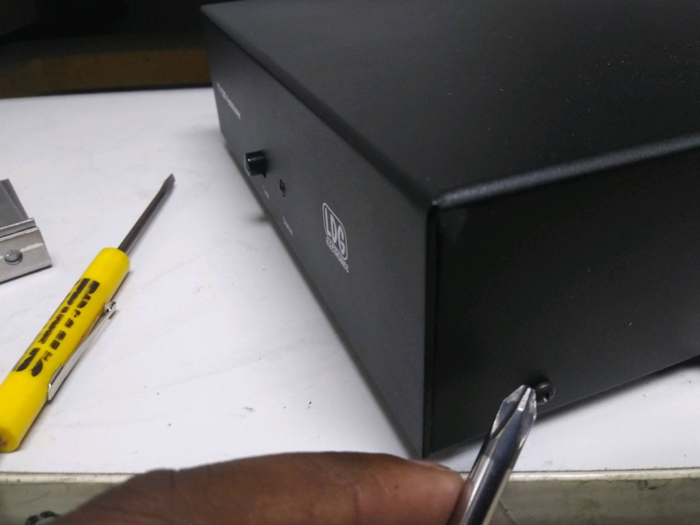
DISASSEMBLE THE ITEM FOR PROPER SIZE RIVET NUT INSERTION
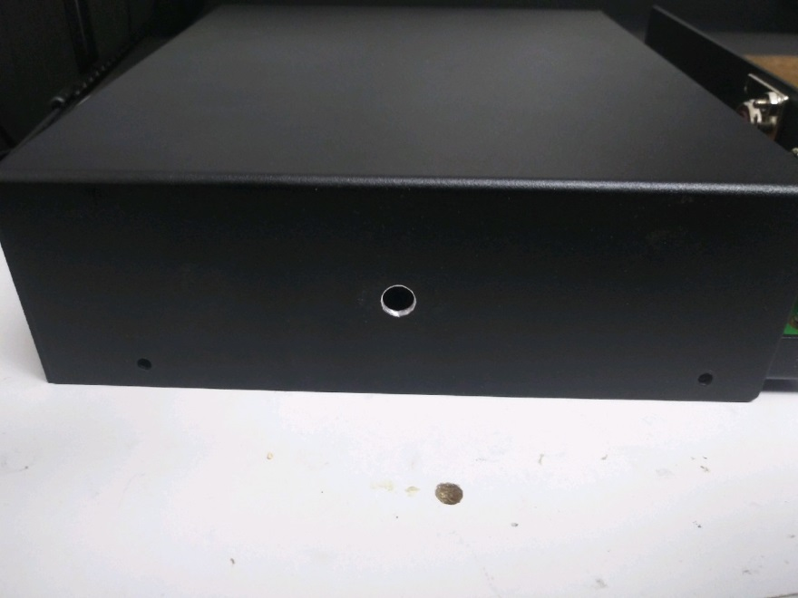
LOCATE THE ELECTRONICS AND AVOID INSTALLING THERE!
DRILL A HOLE IN EACH SIDE USING 17/64” DRILL BIT

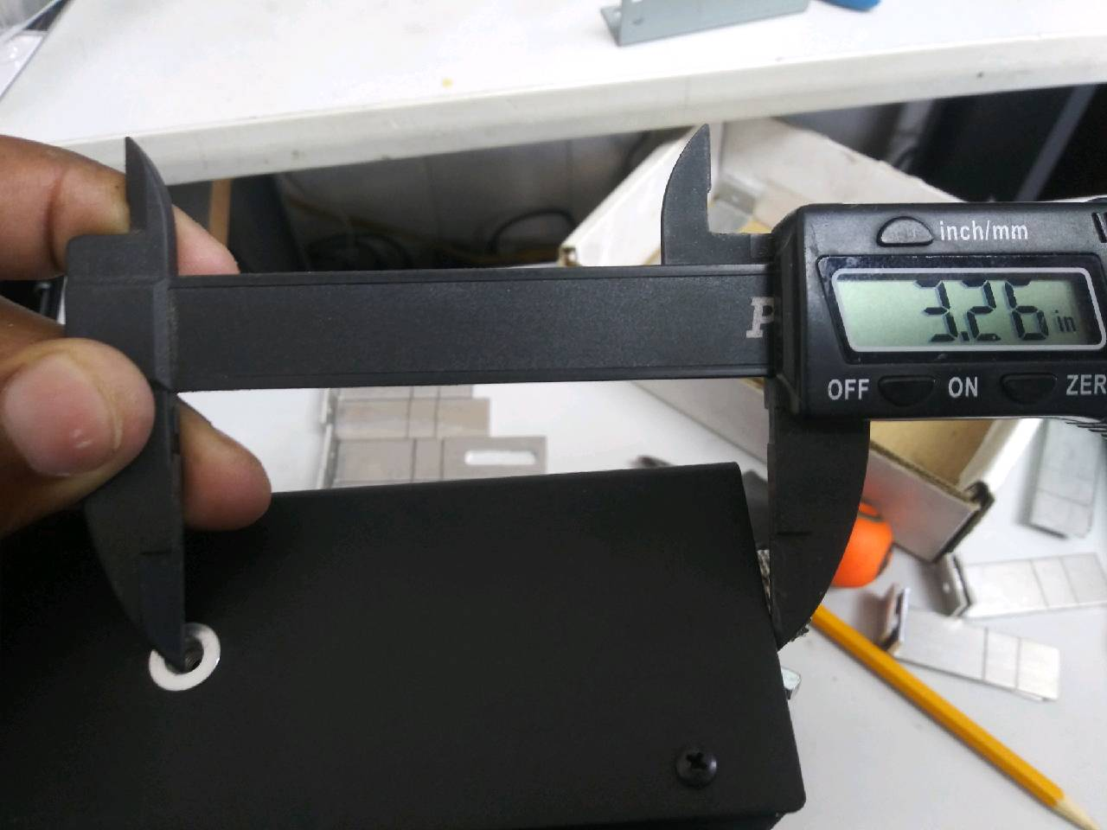
MEASURE FOR DRILLING: 3.26” TO FRONT OR BACK AS THE HOLE WILL BE CENTERED

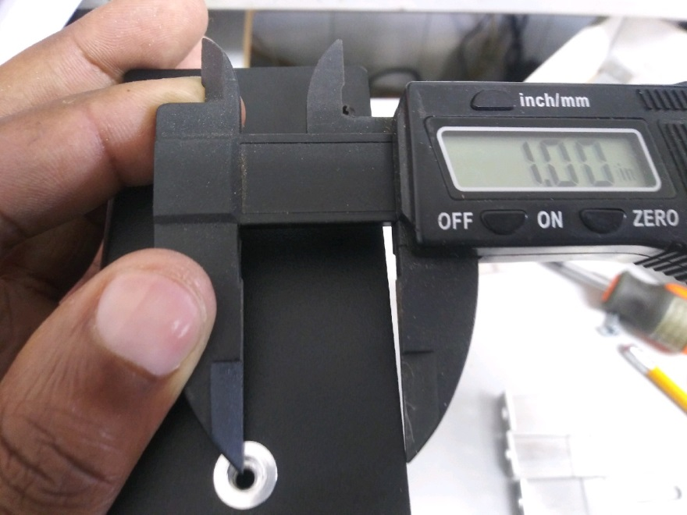
MEASURE TOP TO BOTTOM; CENTER THE HOLE LOCATION AND MARK FOR DRILLING HERE
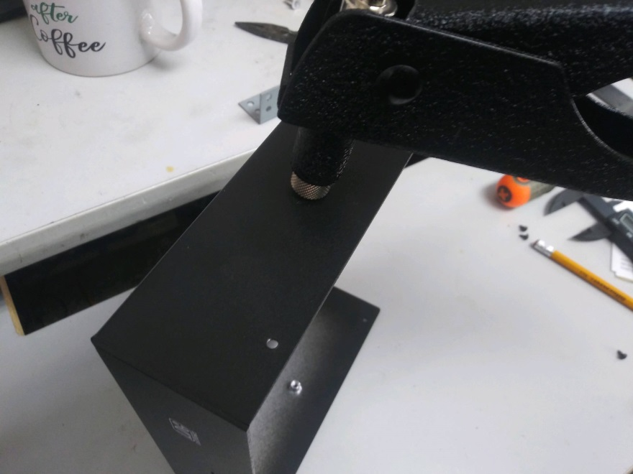
INSERTING THE TOOL WITH 8-32” RIVET NUT ATTACHED, USE THIS SIZE FOR LDG TUNERS & GX5500 ROTOR CONTROL TOO

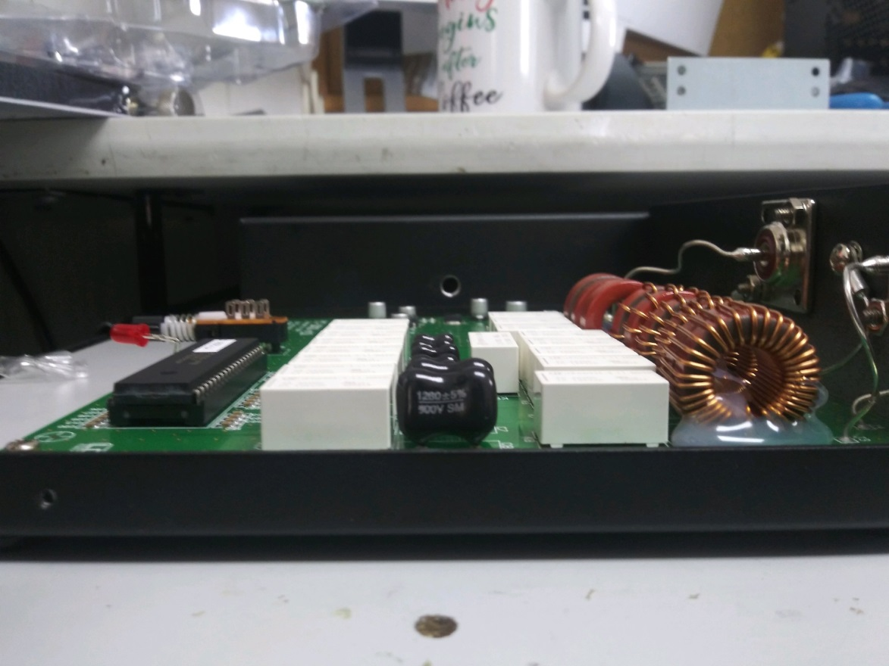
VIEW OF HOW THE RIVET NUT HOLE MISSES THE ELECTRONICS
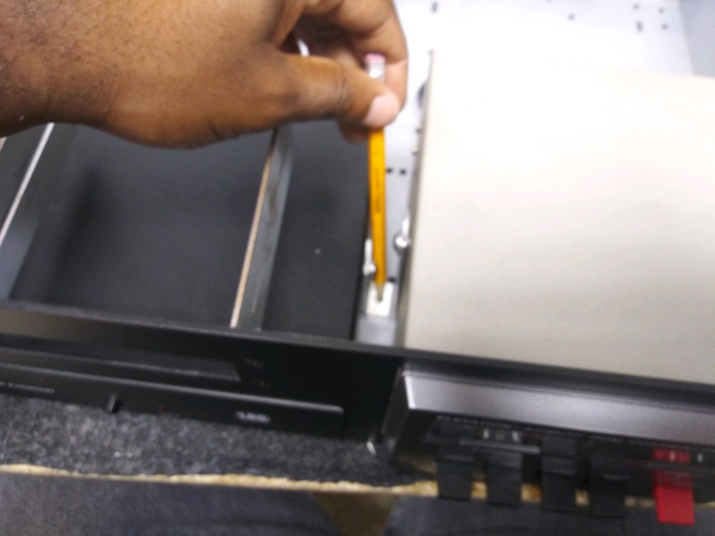
FOR 90 DEGREE “L” BRACKET MOUNT LOOSELY ATTACH AND MARK IT
